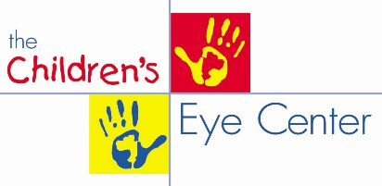
319-366-4455
www.creyecare.com

PRE-CONCUSSION VISION ASSESSMENT RESULTS

Name:_____________________________________ Date:______/_______/________

Date of Birth:______/_______/________ Age:_______________________

Baseline Testing Results:
Results of Eye Teaming: Convergence NPC:____________ Depth Perception__________Sec of Arc

Results of Dynamic Acuity: OD__________OS___________

Results of Eye Focus: Balance of Focus: NRA______________PRA____________

Amplitude of Focus: Right Eye_______________ Left Eye_____________

Results of King-Devick Baseline Testing: Total Time___________ Total Errors_____________

Results of K-D Eye Movement Screening for Reading: Pass________Below Average_______Fail_________

KEEP THESE BASELINE RESULTS FOR YOUR RECORDS

- These results will be used for comparison to help detect the presence of a concussion and determine if the visual system has been affected.

- Back to Baseline helps determine when your athlete can safely “Return to Learn and Return to Play.”

If you suspect a concussion you may choose:
- In-office Post Concussion Vision Assessment: Typically billable to medical insurance
- Purchase the sideline King-Devick Test:
- Go to http://www.kingdevicktest.com/purchase
- Scroll down to King-Devick Test Subscription
- Add subscription to your cart. You may purchase more than one subscription.
- Cost is $20 per athlete for a one year subscription. Your subscription includes: One year of unlimited King-Devick concussion screenings, per athlete. The King-Devick app is free and wifi not required for use.
- Use the baseline Testing results for comparison.
Over 90% of concussion patients experience vision related symptoms. SUNY
Remember to schedule your athlete’s post-concussion vision assessment if a medically based concussion diagnosis is made.

